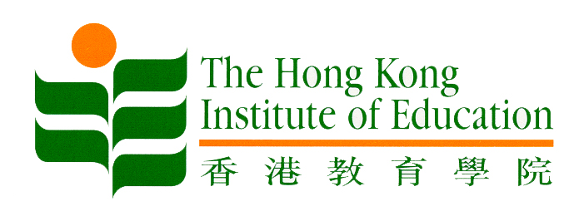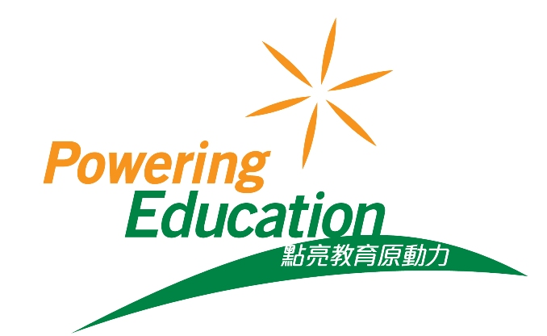
7 April 2016
HKIEd Confers Honorary Fellowships
on Six Distinguished Individuals
Photos of the event are available on HKIEd’s website:
http://www.ied.edu.hk/web/news.php?glang=en

The Hong Kong Institute of Education (HKIEd) has named six distinguished individuals as Honorary Fellows in recognition of their remarkable accomplishments and contributions to the Institute and the community. They are (in alphabetical order of surname):

Dr Alman Chan Siu-cheuk
Mr Alfred Chan Wing-kin, BBS
Mr Chung Po-yang, SBS, OBE, JP
Ms Lillian Lui Lai-hung
Mr Ma Siu-leung, BBS, MH
Mr Andrew Tse Chung-yee

Mr Pang Yiu-kai, HKIEd Council Chairman, presided over the 2016 Honorary Fellowship Presentation Ceremony held at the Tai Po campus today (7 April).

Professor Stephen Cheung Yan-leung, HKIEd President, paid tribute to the recipients, saying “the Honorary Fellows this year are distinguished in different areas and yet have the commonalities of devoting their entire lives to Education or making contributions through their service in various capacities related to Education. They are truly role models whose positivity is so much admired and genuinely needed in Hong Kong nowadays”.

Professor Cheung also took the opportunity to update the Institute community on the encouraging progress achieved in relation to the Institute’s pursuit of university title. He said that the Institute is now awaiting the resumption of the second reading and subsequently the third reading of the HKIEd (Amendment) Bill 2016 in the Legislative Council. “This implies that we are very close to the finishing line of our decade-long journey towards university title”, he commented.

Professor Cheung added that the latest rankings of HKIEd released by Quacquarelli Symonds (QS) last month came as a strong morale booster as the Institute had been working tirelessly on the University title. In the latest rankings, the Institute emerged 2nd in Asia and 12th in the world in Education, breaking its own record of last year.

Professor Cheung also gave his assurance that the future Education University of Hong Kong would continue to be dedicated to Education, a place where aspiring young people could realise their dreams of becoming competent and caring professional teachers, and where scholars could push forward knowledge frontiers through research and knowledge creation.

HKIEd has held the Honorary Fellowship Presentation Ceremony since 2009 to salute outstanding members of the community who devote their energy and talent to their roles as school principals and teachers, and exemplary leaders in various professions, business sectors and industries.

Appendix:
Speech by Professor Stephen Cheung Yan-leung, HKIEd President
Citations for Honorary Fellowship recipients
Biographies of Honorary Fellowship recipients

~ Ends ~

For media enquiries, please contact Ms Sharon Ng (Tel: 2948 6053/9197 7876) and Ms Helen Mok (Tel: 2948 6054/9198 2489) of the Communications Office at HKIEd.

